 |  | ISO 9001:2008  Management system  Certified by | 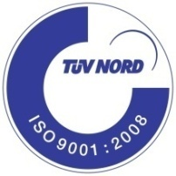

Nanocryst
Crystallization penetrates waterproofing

How it waterproofing:

Untreated concrete is a porous system, which is prone to water penetration. NANOcryst Px100 is applied to the concrete surface. The active ingredients of NANOcryst Px100 start to penetrate into the capillary pores of concrete. Inside the capillary pores the chemicals re-act with the free lime and moisture, and forming insoluble crystalline fibers. So that water cannot be penetrated thru this capillary pores.

Typical uses:

- Basement floor and retaining wall.
- Foundation. Column. Elevator pit.
- Concrete water tank (potable and non-potable),
- Wastewater tank. Water catchments basin. Manhole.
- Aquarium. Tunnel. Underground structures.

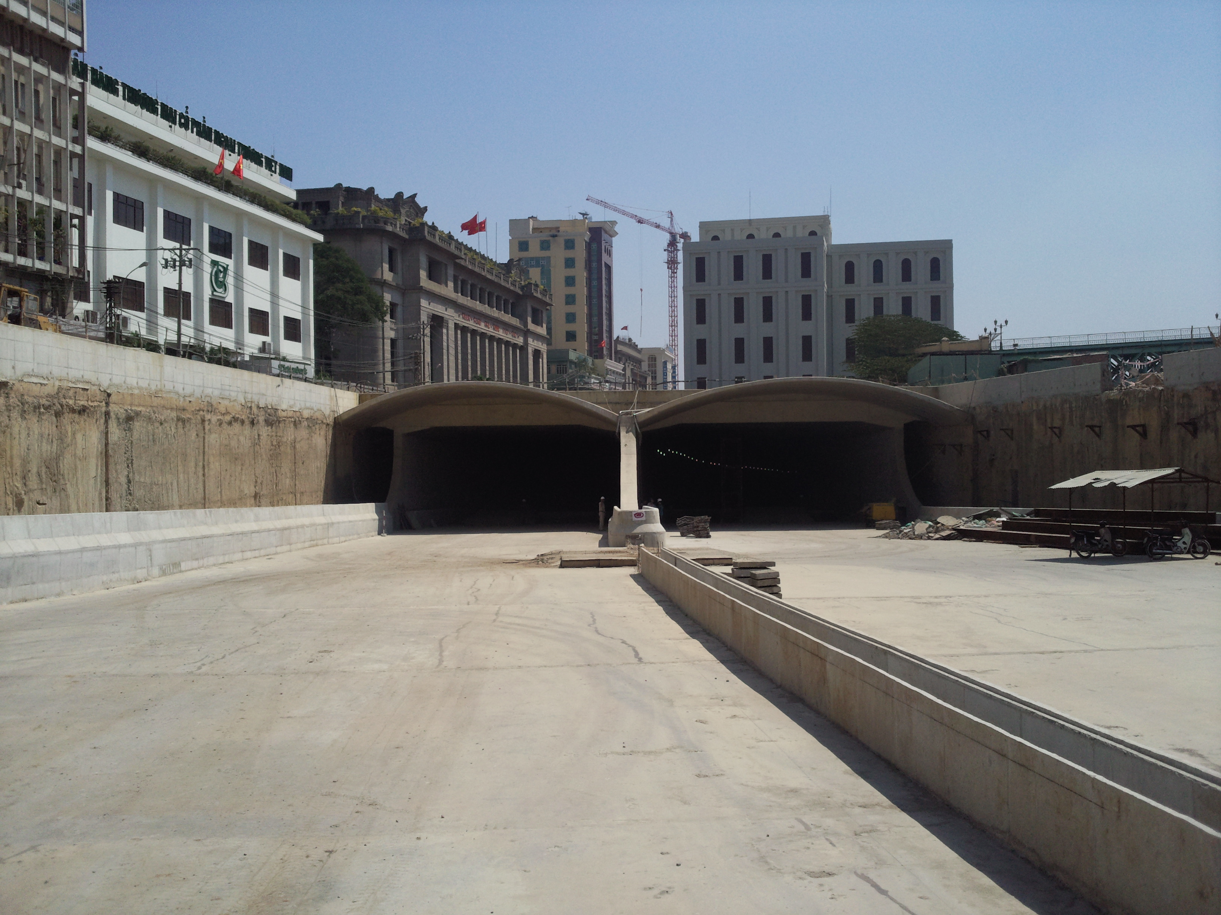
Nanocryst px100 is approved to apply for saigon river tunnel project.

Nanocryst® px100
Crystallization Penetrates Waterproofing

Product description

NANOcryst Px100 crystallized waterproofing coating is consists of special cement and NANO crystallized additive, which react with moisture and free lime in the concrete, creating insoluble crystalline complexes which seal the capillaries of concrete and minor shrinkage cracks. It is suited for protecting new or old structurally sound concrete, permanently sealing it from water penetration, damp proof, and at the same time it can improve the strength of concrete. Resists other harmed chemicals corrosion, and resist freeze-thaw cycle and protect concrete structures.

Standard: ASTM E514-04 and GB18445.

Application areas

NANOcryst Px100 is recommended for below grade positive side and negative side waterproofing.

- Basements floor and retaining walls.
- Foundations. Columns. Elevator pits.
- Water tanks (potable and non-potable). Wastewater tanks.
- Water catchments basins. Manholes. Marine aquariums
- Parking garages. Tunnels. Underground structures.

Advantages

- Non-toxic, odorless, environmentally friendly
- Permanently active
- Potable water approved
- Easy to use, only needs water for mixing.
- Can be applied to green concrete as soon as forms are stripped
- Protects concrete against fresh water, salt water, waste water & aggressive ground water
- Brush, dry – sprinkle or spray applied
- Resists strong hydrostatic pressure
- Seals and post seals shrinkage cracks, up to 1/64” (0.4mm). Contains no chlorides
- Protects concrete in-depth-concrete remains waterproof even if coating is damaged
- Applied to positive (active) or negative (passive) water pressure.

Properties

NANOcryst Px100 penetrates deep inside the concrete even against strong hydrostatic pressure becoming an integral part of the concrete. The waterproofing chemicals remain active for the life of the structure permanently sealing it from water penetration. Unlike a membrane NANOcryst Px100 may require up to one month to- reach its maximum waterproofing capability. Environmental factors such as ambient temperature, density of concrete, moisture present and weather conditions all can affect the timing of the sealing process. Under dry conditions the chemicals lie dormant, however they reactivate whenever re exposed to moisture, NANOcryst Px100 post seals shrinkage cracks up to 1/64” (0.4mm), which occur after the product has been applied and cured. Concrete treated with N NANOcryst Px100 is highly resistant to most aggressive substances, pH 4-11 constant contact and pH 2-12 periodic contact. In addition it protects against rebar corrosion, spalling, freeze/thaw cycles and weather related damage.

Technical specification

Supply form | Powder
Color after mixed | Gray
Packaging | 25 kg damp-proof bag
Shelf life | 12 month in it unopened bag.
Storage | Store above pallet in room temperature. Avoid humidity

APPLICATION INSTRUCTION

Surface preparation

Clean the surface thoroughly removing all grease, oil, or other foreign substance present, and get rid of all loose particles of concrete, exposing a clean, hard and flat surface to allow a flawless coat of uniform thickness to be applied.
Any open cracks or porous holes should be filled with mortar before apply.
The best recommending method in cleaning the large area of vertical or horizontal concrete surface is using sandblast or swept by high-pressure water jet.
All the surfaces should be thoroughly saturated with water sometime before the application, allowing it to seep in, but not to dry, to avoid a too rapid water loss.

Application: There are 3 methods to application.

Brush application

Wet and saturate the substrate with clean water. While the surface still remains damp, use a flat paintbrush apply NANOcryst Px100 regularly over the damp surface. Allow the coating of NANOcryst set and tack free, continuous apply the second coat of NANOcryst Px100 perpendicularly to the first coat with the same method.
Water ratio for mixing: Use about 5 to 6 liters of clean water to mix with one bag of 25 kg of NANOcryst Px100.

Spray application

Wet and saturate the substrate with clean water. While the surface still remains damp, Use suitable plaster spray equipment (Do not use high pressure or airless spray equipment) spray NANOcryst Px100 regularly over the damp surface from the top to the bottom. Allow the first coat of NANOcryst Px100 set and tack free, continuous apply the second coats with the same method.
Water ratio for mixing: Use about 7.5 to 8.0 liters of clean water to mix with one bag of 25 kg of NANOcryst Px100.

Mixing

Use a plaster mixer with suitable blades or a driller (400 – 600 rpm) with a mixing paddle.
Pour the ¾ gauging of water into a clean container, then slowly adds NANOcryst Px100 into the water, mixed well until it becomes homogenous mixture and completely free of lump. After initial mixing, allow material to rest for 3 – 5 minutes then re-mix and add remaining water to adjust the consistency for application.

Dry spread application

Wet the substrate with clean water. Spread the dry powder of NANOcryst Px100 onto the damp surface about 2 kg/m2. Pour the fresh concrete over NANOcryst Px100, and continuous with the same method for the other areas.

Important notes

- Use all the mixture during 30 minutes.
- Do not add more water after the mixture becomes gel.
- The application thickness is at least 2 mm.
- Curing time is 3 days.
- Exposure to rain and water must be avoided during 24 hours.

Cleaning tools

All tools must be cleaned with water immediately after use. Hardened material can only be removed by mechanically.

Physical properties: GB 18445 Standard

No. | Characteristics |  | Result
1 | Stability after mixed |  | Qualified
2 | Setting time | Initial setting time (minute) | > 20
2 | Setting time | Final setting time (hour ) | < 24
3 | Flexural strength (MPa) | 7 days | > 2.80
3 | Flexural strength (MPa) | 28 days | > 3.50
4 | Compressive strength (MPa) | 7 days | > 12.0
4 | Compressive strength (MPa) | 28 days | > 18.0
5 | Wet substrate adhesive strength (MPa) |  | > 1.0
6 | Impermeability pressure (28 days) MPa |  | > 0.8
7 | 2nd Impermeability pressure (56 days) MPa |  | > 0.6
8 | Osmotic pressure ratio (28 days) % |  | > 200

APPLICATION AREAS

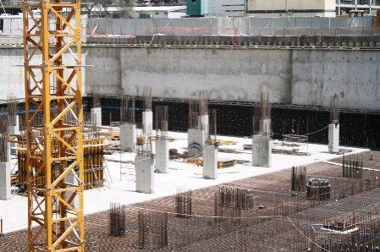 | 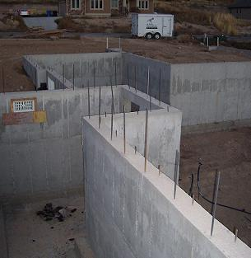
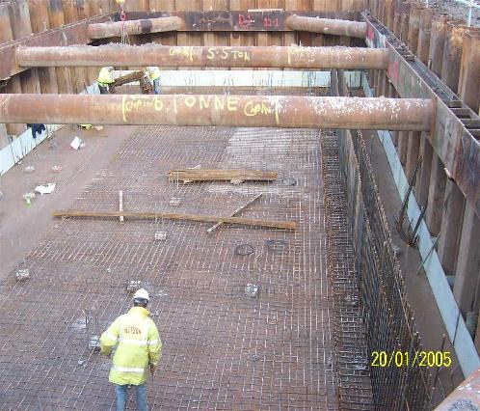 | 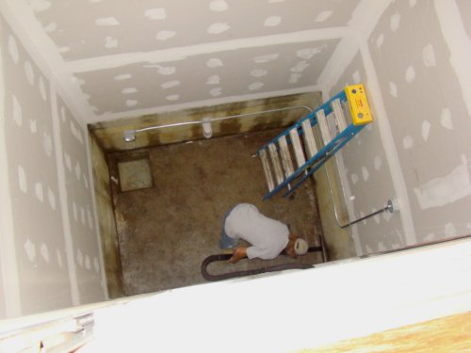
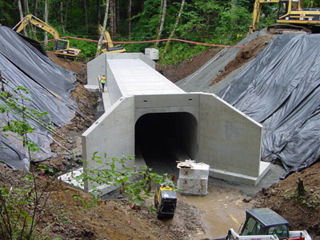 | 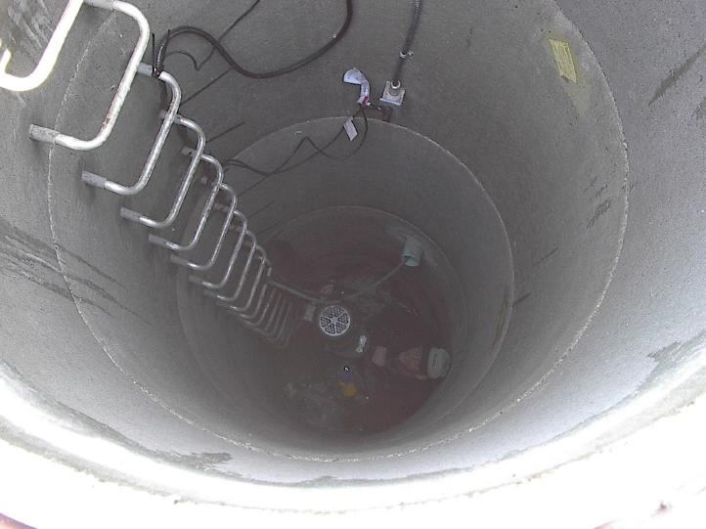
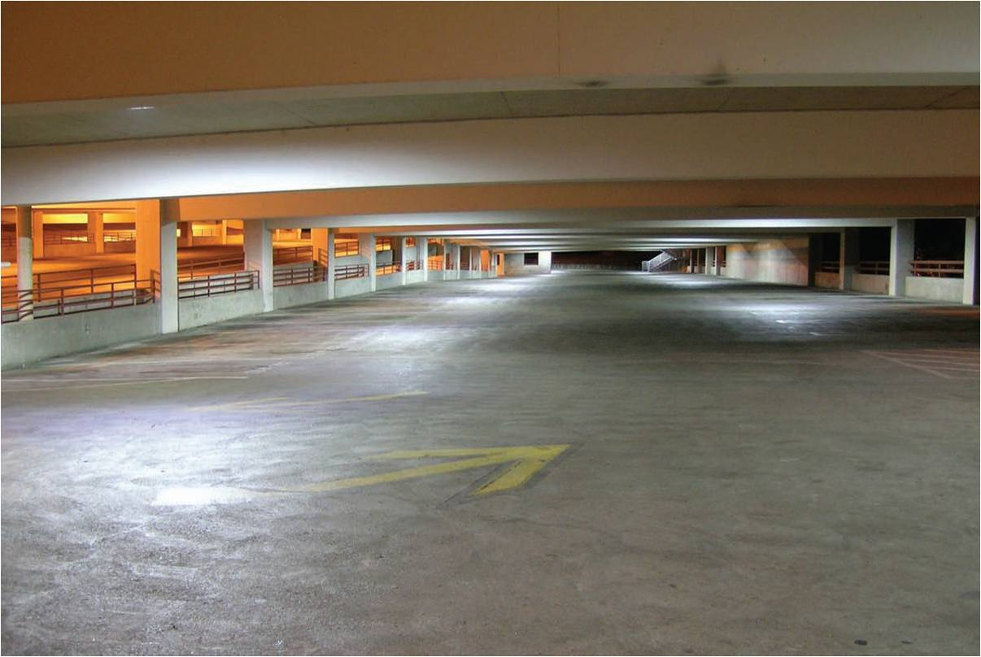 | 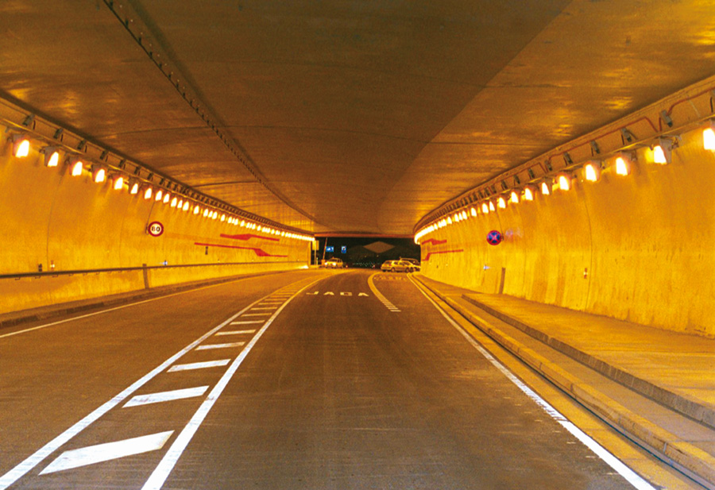
The above pictures only for refer.

Advanced Building Chemical

